AP63300 24V/5V Buck Converter Module

Description
This module is a step-down buck converter utilizing the Diodes Incorporated AP63300 (TSOT-23-6/TSOT-26) chip. It converts a 24V input into a regulated 5V output, and is capable of supplying 3A continuously. The board is 30x30 mm with four M2 mounting holes spaced 25x25 mm apart. The module features a 1x3 2.54 mm through-hole header for VIN, VOUT, and GND, making it compatible with prototype boards.

Design Notes
- Regulator: The AP63300 accepts 3.8–32 V and delivers up to 3 A. Its feedback reference is 0.8 V and its switching frequency is 500 kHz. The component values follow the datasheet’s typical application circuit and the manufacturer’s evaluation board.
- Feedback divider: The divider scales the output voltage down to the 0.8 V feedback reference. The controller compares FB to that reference and adjusts the duty cycle to keep Vout at 5 V.
- Inductor: L1 = 6.8 µH (Würth 784775068). At 24 V in and 5 V out the duty cycle is about 21 %, and the inductor ripple current is ΔI = Vout × (1 − Vout/Vin) / (L × fsw) ≈ 1.2 A peak-to-peak. At 3 A load, the peak current is ~3.6 A, which is below the inductor’s saturation current of 3.8A (The inductor is rated for 3.7A overall, so the margin is small).
- Input capacitor: C1 = 10 µF, 50 V X7R, 1210. The 50 V rating leaves margin for the 24 V input and the loss of capacitance under DC bias.
- Output capacitors: C21 and C22 are 22 µF, 25 V X7R, 1210, giving 44 µF nominal.
- Bootstrap capacitor: C3 = 100 nF between BST and SW.
- Feed-forward capacitor: C4 = 47 pF across the upper feedback resistor R1, as in the datasheet’s application circuit.
- Enable: The EN pin is tied to VIN, so the converter starts as soon as the input is applied.
- Layout: The input capacitor is placed next to the IN and GND pins to keep the high-current loop small. The bootstrap capacitor sits right next to BST and SW. The feedback network is kept away from the switching node. Power tracks (VIN, VOUT, GND) are 1 mm wide, and the bottom layer is a solid GND plane connected to the top layer by stitching vias.

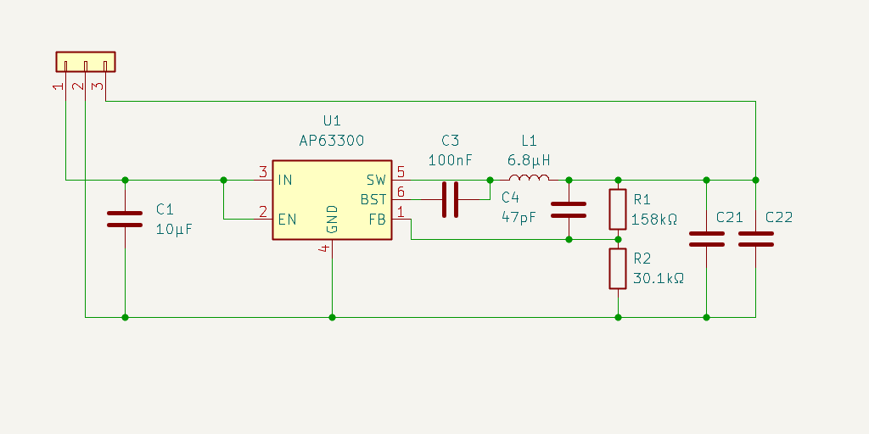
Schematic

Bill of Materials
Ref | Quantity | Value | Footprint | Datasheet | # | MPN
J1 | 1 | Conn_01x03 | Connector_PinHeader_2.54mm:PinHeader_1x03_P2.54mm_Vertical | link | 1 | PH1-03-UA
U1 | 1 | AP63300 | Package_TO_SOT_SMD:TSOT-23-6 | link | 2 | AP63300WU-7
R1 | 1 | 158kΩ | Resistor_SMD:R_0603_1608Metric | link | 3 | RC0603FR-07158KL
R2 | 1 | 30.1kΩ | Resistor_SMD:R_0603_1608Metric | link | 4 | RK73H1JTTD3012F
C21, C22 | 2 | 22μF | Capacitor_SMD:C_1210_3225Metric | link | 5 | FTC1210X7R250-226KNE
C1 | 1 | 10μF | Capacitor_SMD:C_1210_3225Metric | link | 6 | AGC1210X7R500-106KNE
L1 | 1 | 6.8μH | Inductor_SMD_Wurth:L_Wurth_WE-PD2A-7850 | link | 7 | 784775068
C3 | 1 | 100nF | Capacitor_SMD:C_0603_1608Metric | link | 8 | CC0603KRX7R7BB104
C4 | 1 | 47pF | Capacitor_SMD:C_0603_1608Metric | link | 9 | 885012006021

Layout Images
Top view with bottom GND pour visible:
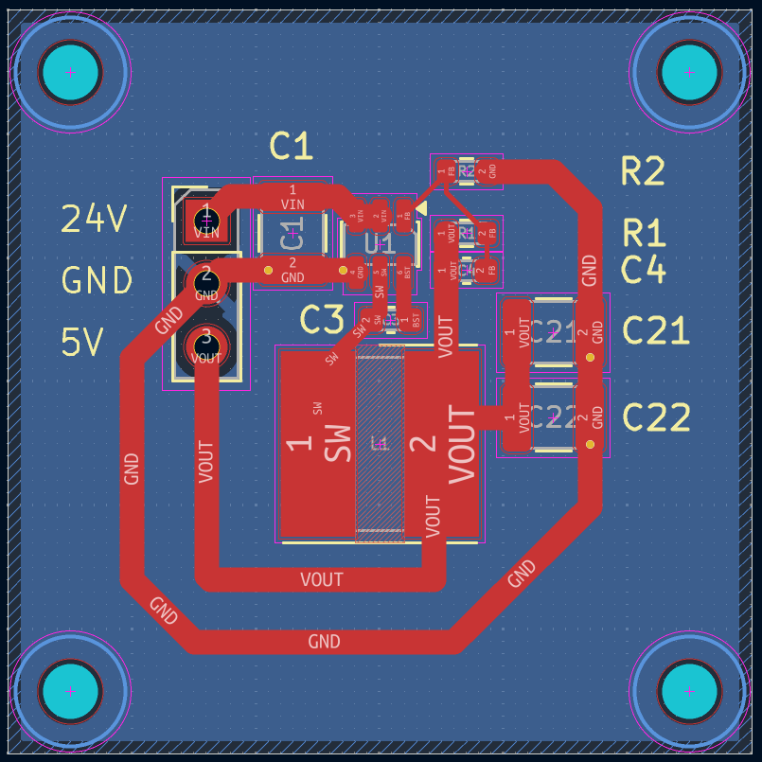

3D View
